Significance

The significance test | The significance test determines the likelihood that a strong correlation is random, and is therefore of no practical significance.  For example, a data set with only two points will always have an r² = 1, but this correlation is not significant.  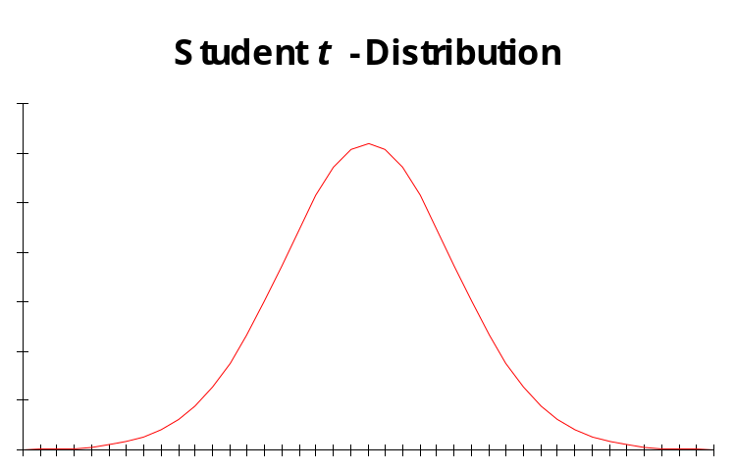

Calculating significance | The procedure for calculating the correlation significance is as follows.  - Compute the value of x, such that  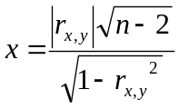  where  - 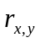 is the correlation  - n is the number of data points  - Find the probability p by numerically integrating the t distribution for n − 2 degrees of freedom, from 0 to x.  - Calculate the tail area as 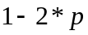. (The area under the curve from –x to +x is twice the area from 0 to x, or 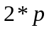; the remaining area in the upper and lower tails is ).  A tail area ≤ 0.05 is considered as strong evidence that there is a relationship.  A tail area ≥ 0.2 indicates a relationship that is due to chance.

Prediction interval

Prediction  interval | The prediction interval provides a likely range around the estimate.  • A 70% prediction interval gives the range within which 70% of the estimates will fall.  • It is not a forecast, only an expectation.  • It only applies if the estimate behaves like the historical data.  It is calculated from the same data used to calculate the regression parameters.

Prediction  interval  procedure | To calculate the prediction interval, use the following steps.  - Calculate the Range for a 70% interval.  - Calculate the UPI as 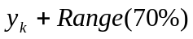.  - Calculate the LPI as 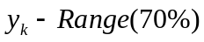 (NOTE: it can’t be negative).  The formula for calculating the prediction range is  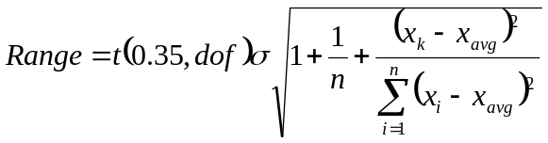  where  • x is your historical data  • n is the number of historical data points  • t(0.35, dof) is the value of x for a t distribution for n - 2 degrees of freedom where p = 0.35  The formula for calculating the standard deviation term is  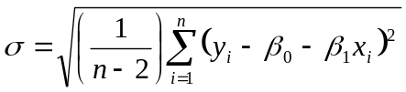  where  • x, y are your historical data  • n is the number of historical data points

